Lab Activity 09 Worksheet
Place your screenshots and / or answers to questions here.
Each Part is 1 point, for a total of 10 points.

Part 1 Screen Shot showing that a 2GB virtual hard drive was added to your virtual machine.
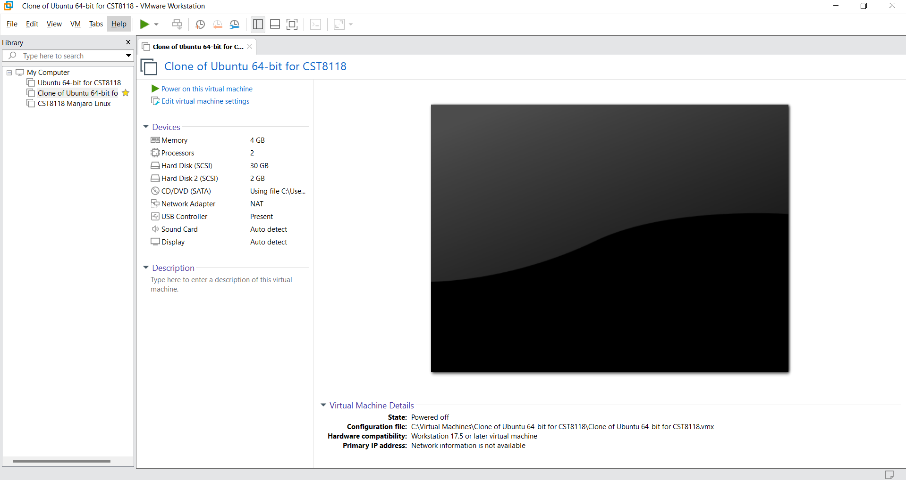

Part 2 Screen Shot of 2GB disk with partitions set up as specified.
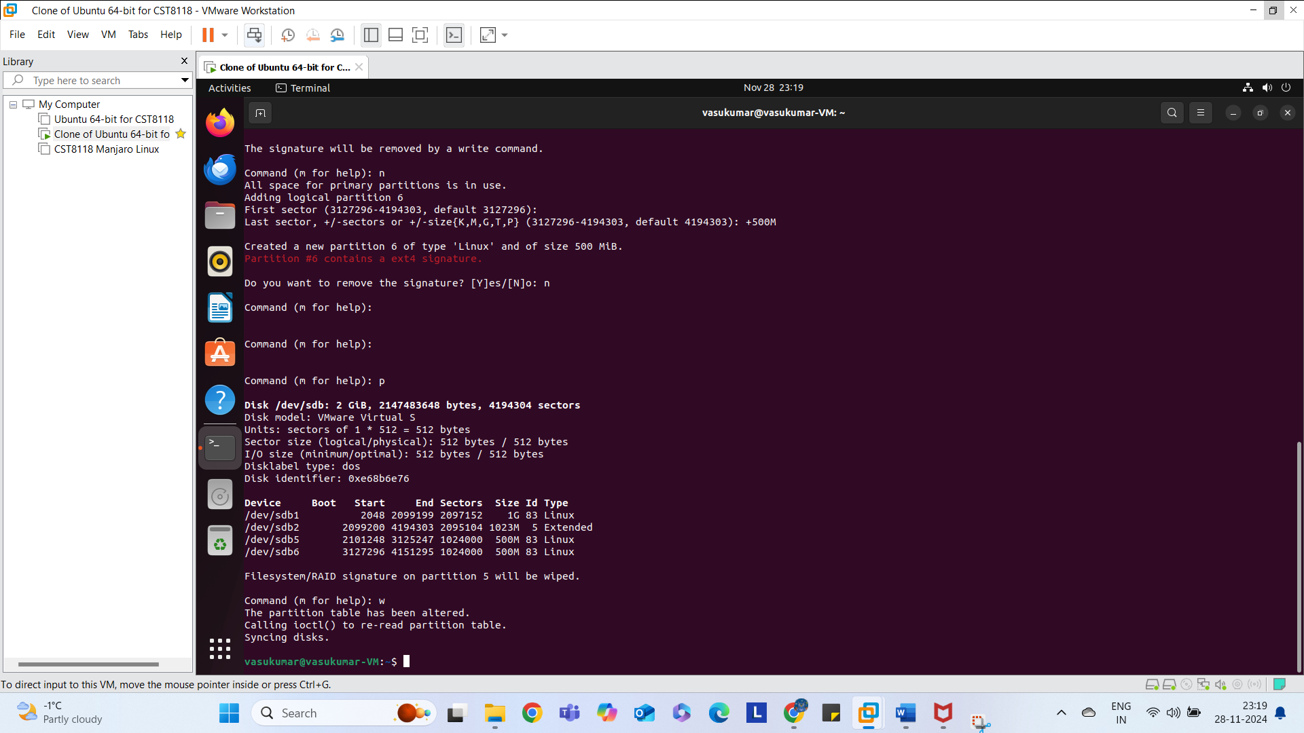

Part 3 Screen Shot of formatting each partition with mkfs to apply Ext4.
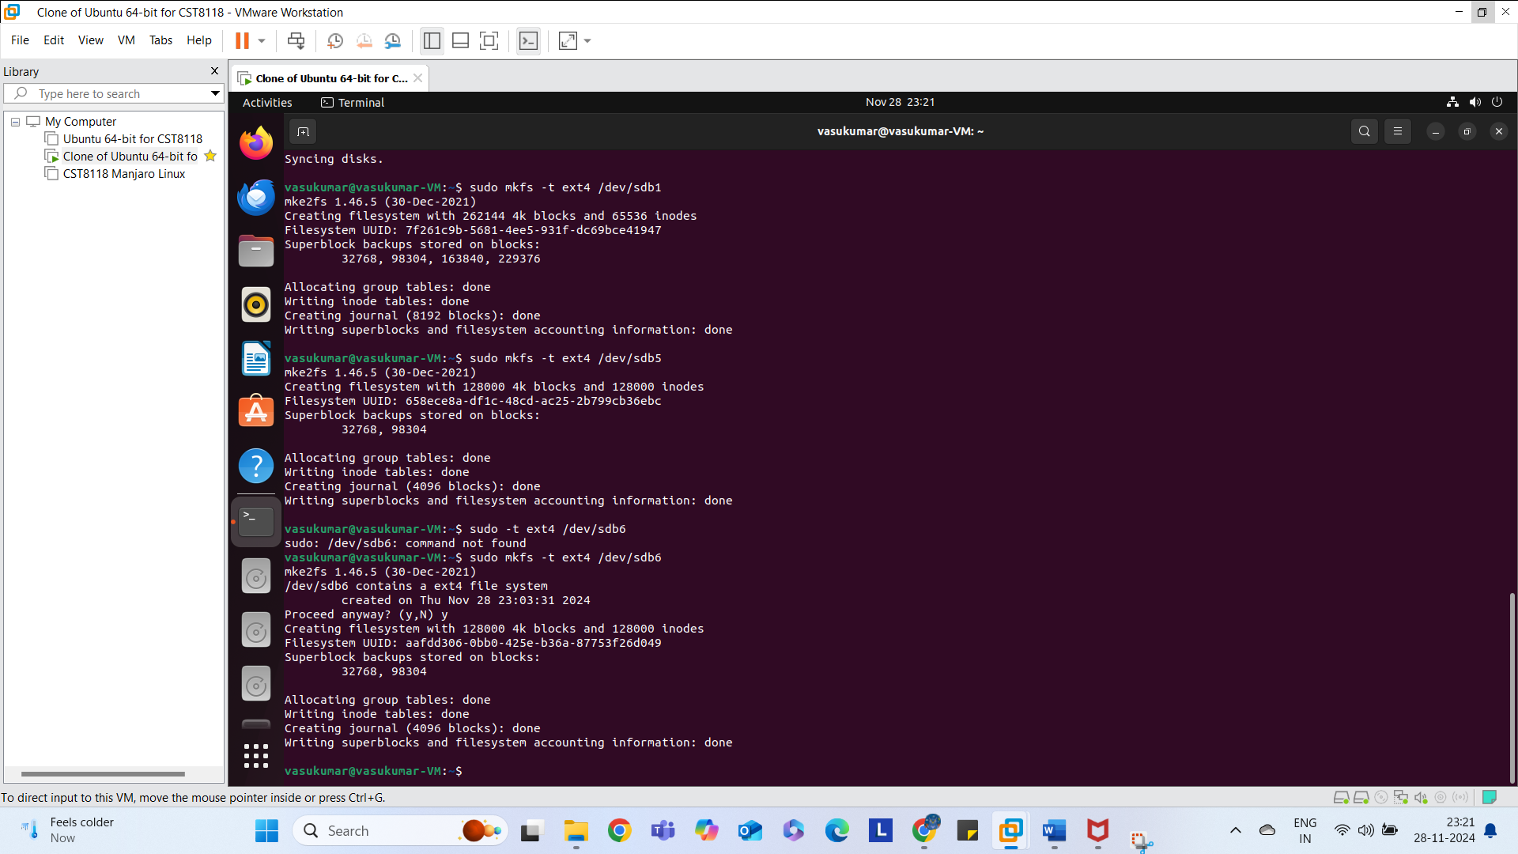

Part 4 Screen Shot of verifying each partitions file system.
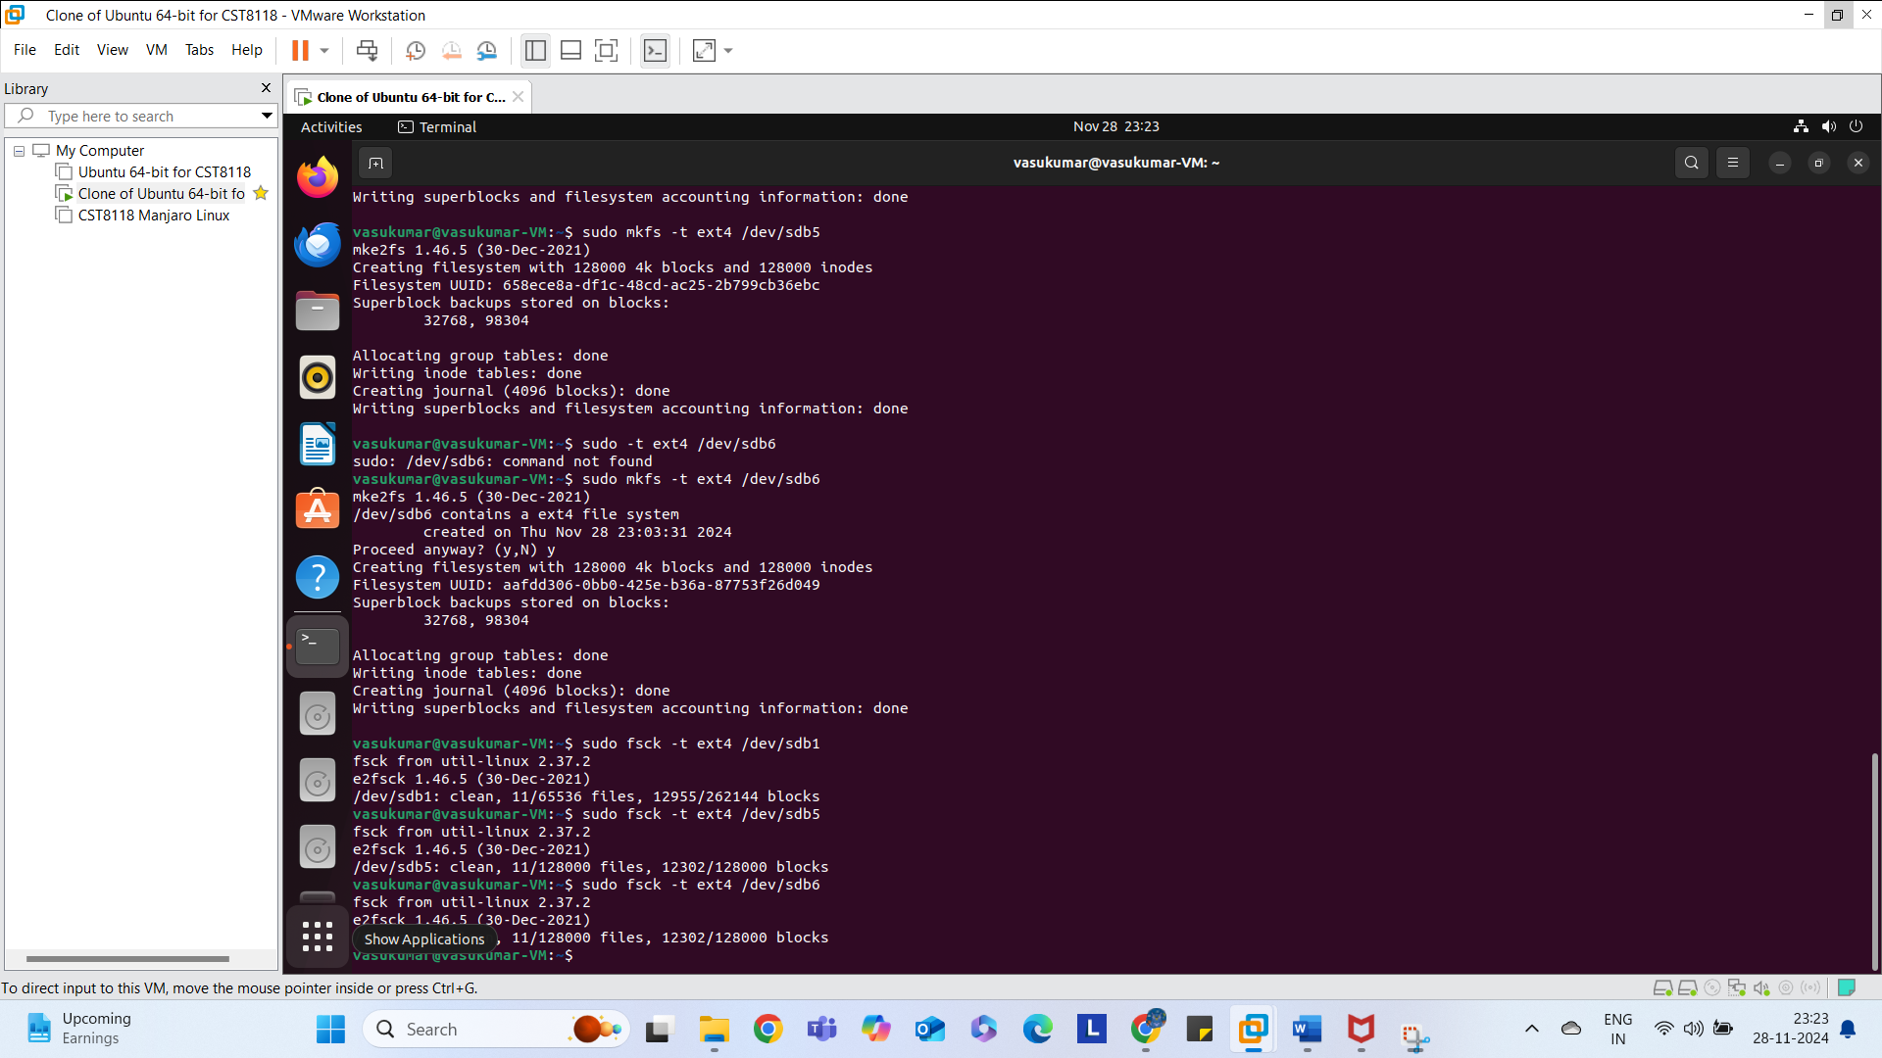

Part 5 Screen Shot of creating a mount-point folder.
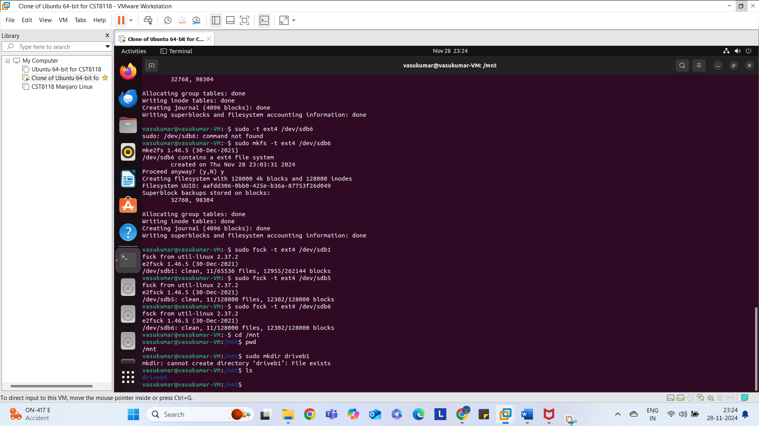

Part 6 Screen Shot of mounting one hard drive.
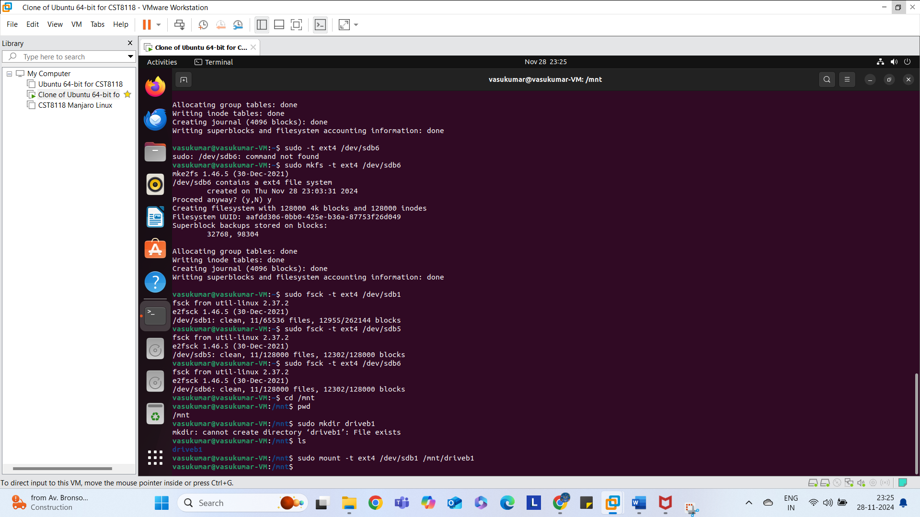

Part 7 Screen Shot of changing permissions on one hard drive.
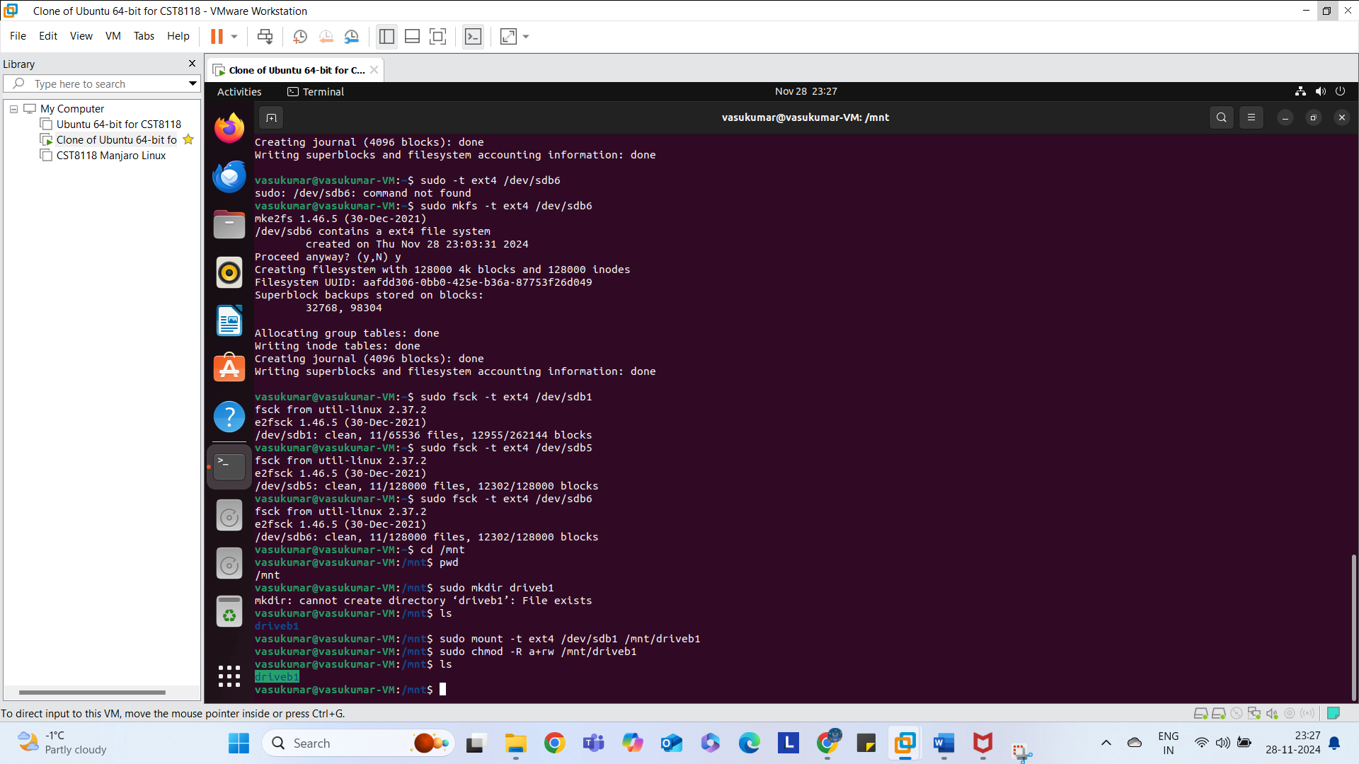

Part 8 Screen Shot of writing and reading text to a mounted hard drive.
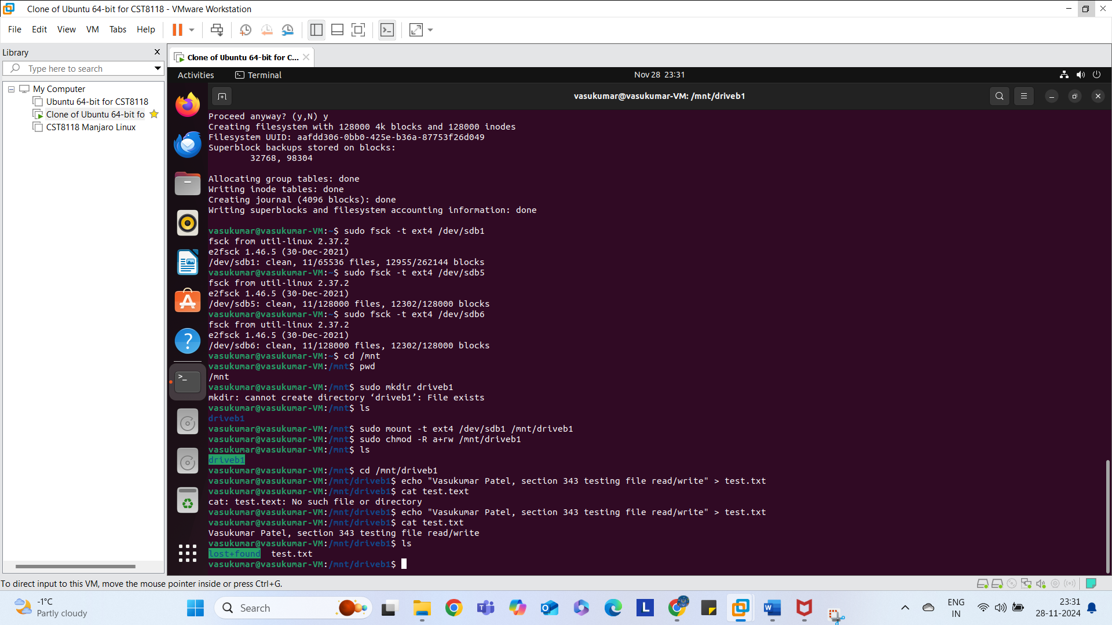

Part 9 Screen Shot of deleting a text file from a mounted hard drive.
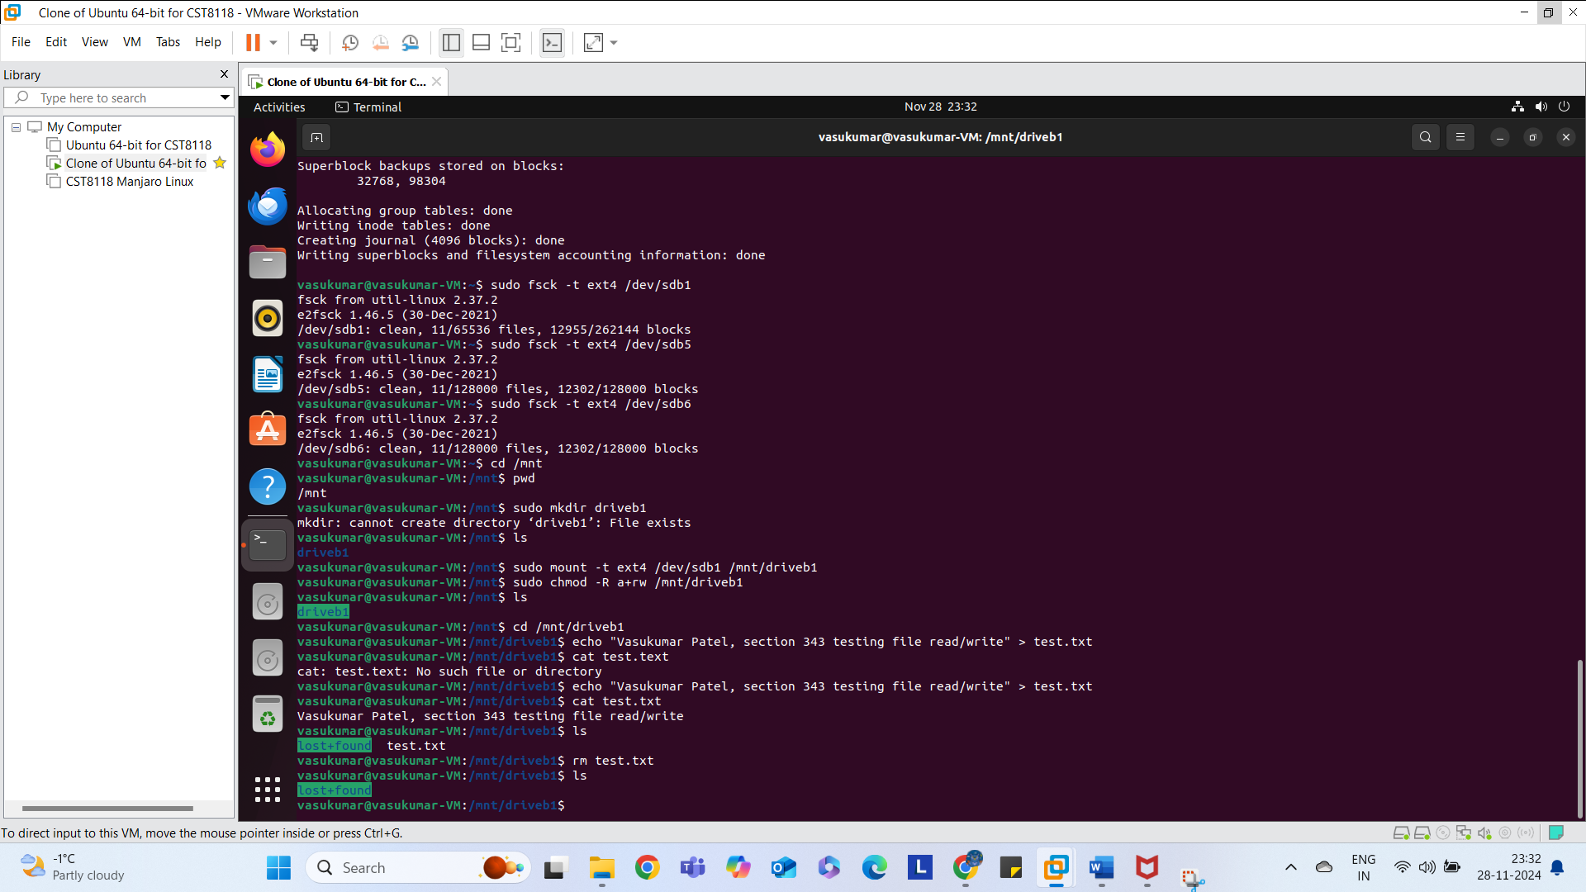

Part 10 Screen Shot of unmounting a hard drive.
